Scalene Acute Triangle
# Source: AI Source: Provided by: [Data Path: Persons Table -> ID Column: 1, Name_En Column: Motasem Essam] -> From: [ChatGPT] on [7/25/2026]
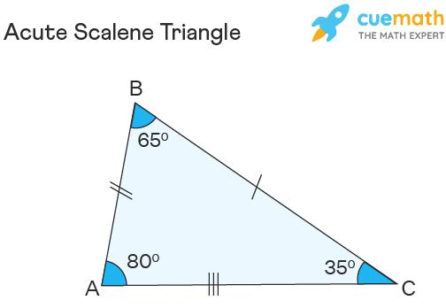
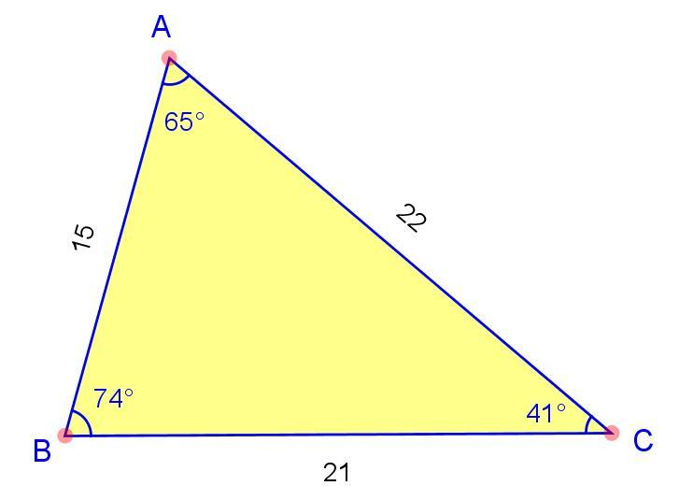
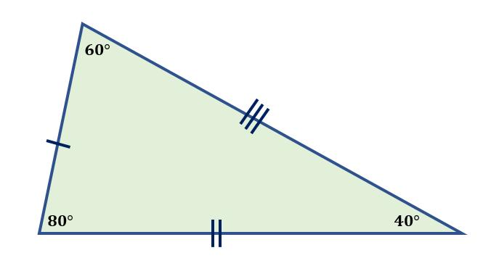
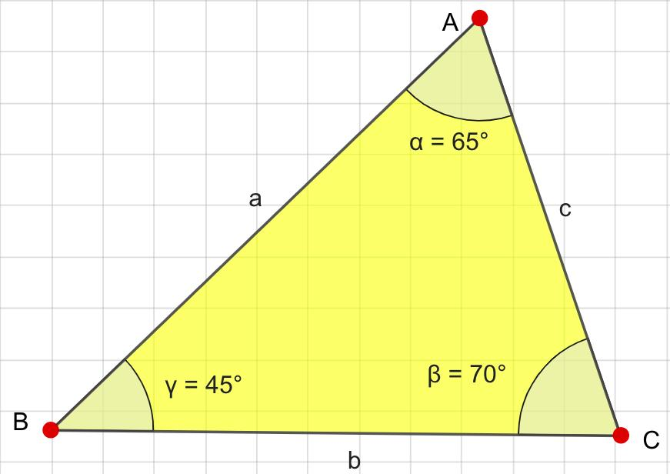

Definition
# Source: AI Source: Provided by: [Data Path: Persons Table -> ID Column: 1, Name_En Column: Motasem Essam] -> From: [ChatGPT] on [7/25/2026]
A Scalene Acute Triangle is a triangle that has:
- Three unequal sides, and
- Three acute interior angles, meaning every angle is less than ${90}^{∘}$.
Thus:
$$\boxed{AB≠BC≠CA}$$
and
$$\boxed{∠A<{90}^{∘}, ∠B<{90}^{∘}, ∠C<{90}^{∘}}$$
The three interior angles always satisfy:
$$\boxed{∠A+∠B+∠C={180}^{∘}}$$

Classification
# Source: AI Source: Provided by: [Data Path: Persons Table -> ID Column: 1, Name_En Column: Motasem Essam] -> From: [ChatGPT] on [7/25/2026]
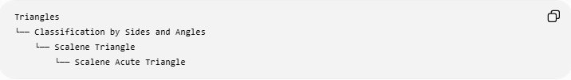
Triangles
└── Classification by Sides and Angles
└── Scalene Triangle
└── Scalene Acute Triangle
Or, using the two independent classification systems:
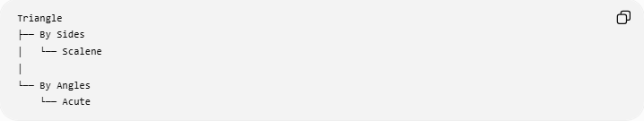
Triangle
├── By Sides
│ └── Scalene
│
└── By Angles
└── Acute
Therefore:
$$\boxed{\text{Scalene Acute Triangle}=\text{Scalene by sides}+\text{Acute by angles}}$$

Fundamental Properties
# Source: AI Source: Provided by: [Data Path: Persons Table -> ID Column: 1, Name_En Column: Motasem Essam] -> From: [ChatGPT] on [7/25/2026]
A scalene acute triangle has:
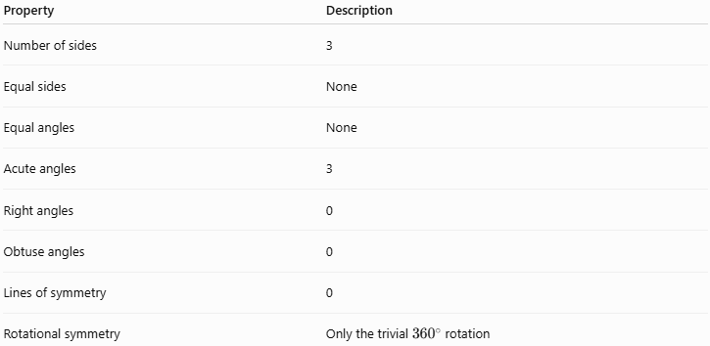
Property | Description
Number of sides | 3
Equal sides | None
Equal angles | None
Acute angles | 3
Right angles | 0
Obtuse angles | 0
Lines of symmetry | 0
Rotational symmetry | Only the trivial ${360}^{∘}$rotation
Because all three sides are different, all three angles are also different.
The largest side is opposite the largest angle, and the smallest side is opposite the smallest angle.

Angle Structure
# Source: AI Source: Provided by: [Data Path: Persons Table -> ID Column: 1, Name_En Column: Motasem Essam] -> From: [ChatGPT] on [7/25/2026]
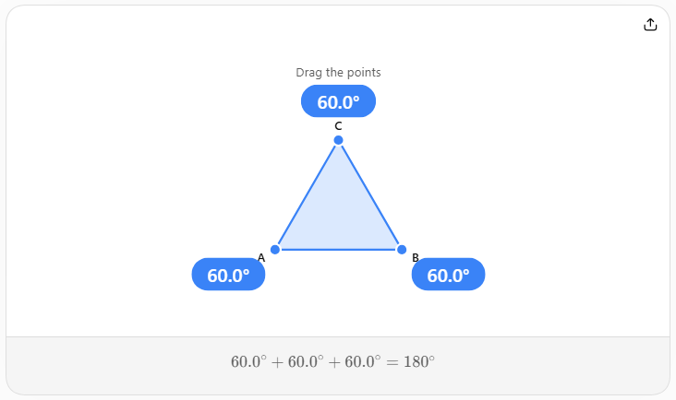
For a scalene acute triangle:
$$\boxed{0^{∘}<∠A,∠B,∠C<{90}^{∘}}$$
and
$$\boxed{∠A+∠B+∠C={180}^{∘}}$$
Since the triangle is scalene:
$$\boxed{∠A≠∠B≠∠C}$$
For example:
$$\boxed{{50}^{∘}+{60}^{∘}+{70}^{∘}={180}^{∘}}$$
All three angles are acute and different.

Side Structure
# Source: AI Source: Provided by: [Data Path: Persons Table -> ID Column: 1, Name_En Column: Motasem Essam] -> From: [ChatGPT] on [7/25/2026]
Suppose the sides are ordered:
$$a<b<c$$
where $c$is the longest side.
The opposite angles have the same ordering:
$$\boxed{∠A<∠B<∠C}$$
Therefore:
$$\boxed{\text{Longest side}↔\text{Largest angle}}$$
and
$$\boxed{\text{Shortest side}↔\text{Smallest angle}}$$

Side-Length Condition for an Acute Triangle
# Source: AI Source: Provided by: [Data Path: Persons Table -> ID Column: 1, Name_En Column: Motasem Essam] -> From: [ChatGPT] on [7/25/2026]
For a triangle with longest side $c$, the triangle is acute when:
$$\boxed{c^{2}<a^{2}+b^{2}}$$
This is the acute-triangle form of the converse of the Pythagorean theorem.
The three cases are:
$$\boxed{c^{2}<a^{2}+b^{2}} ⇒ \text{Acute} \\ \boxed{c^{2}=a^{2}+b^{2}} ⇒ \text{Right} \\ \boxed{c^{2}>a^{2}+b^{2}} ⇒ \text{Obtuse}$$
For a scalene acute triangle, the first condition applies and all three sides must be different.

Triangle Inequality
# Source: AI Source: Provided by: [Data Path: Persons Table -> ID Column: 1, Name_En Column: Motasem Essam] -> From: [ChatGPT] on [7/25/2026]
The side lengths must also satisfy the triangle inequality:
$$\boxed{a+b>c} \\ \boxed{a+c>b} \\ \boxed{b+c>a}$$
When $c$is the longest side, checking
$$\boxed{a+b>c}$$
is sufficient to verify the remaining inequalities.

Altitudes
# Source: AI Source: Provided by: [Data Path: Persons Table -> ID Column: 1, Name_En Column: Motasem Essam] -> From: [ChatGPT] on [7/25/2026]
A scalene acute triangle has three altitudes.
Each altitude begins at a vertex and meets the opposite side at a point inside the triangle.
$$\boxed{h_{a}⊥BC} \\ \boxed{h_{b}⊥AC} \\ \boxed{h_{c}⊥AB}$$
Unlike an isosceles triangle, none of these altitudes generally coincides with a median or angle bisector.

Medians
# Source: AI Source: Provided by: [Data Path: Persons Table -> ID Column: 1, Name_En Column: Motasem Essam] -> From: [ChatGPT] on [7/25/2026]
There are three medians:
$$\boxed{m_{a}, m_{b}, m_{c}}$$
Each connects a vertex to the midpoint of the opposite side.
Because the triangle is scalene, the medians generally have different lengths.
All three medians intersect at the centroid $G$.
$$\boxed{AG:GM=2:1}$$
and similarly for the other medians.

Angle Bisectors
# Source: AI Source: Provided by: [Data Path: Persons Table -> ID Column: 1, Name_En Column: Motasem Essam] -> From: [ChatGPT] on [7/25/2026]
There are three internal angle bisectors.
They intersect at the incenter $I$.
Because the triangle is scalene, the angle bisectors generally have different lengths.
The incenter is inside the triangle:
$$\boxed{I∈\text{interior of the triangle}}$$

Perpendicular Bisectors
# Source: AI Source: Provided by: [Data Path: Persons Table -> ID Column: 1, Name_En Column: Motasem Essam] -> From: [ChatGPT] on [7/25/2026]
Each side has a perpendicular bisector.
The three perpendicular bisectors intersect at the circumcenter $O$.
Because the triangle is acute:
$$\boxed{O∈\text{interior of the triangle}}$$
This is an important distinction from an obtuse triangle, whose circumcenter lies outside.

Orthocenter
# Source: AI Source: Provided by: [Data Path: Persons Table -> ID Column: 1, Name_En Column: Motasem Essam] -> From: [ChatGPT] on [7/25/2026]
The three altitudes intersect at the orthocenter $H$.
Because the triangle is acute:
$$\boxed{H∈\text{interior of the triangle}}$$
Thus, for a scalene acute triangle, the four principal centers are all inside:
$$\boxed{G, I, O, H\text{ are inside}}$$

Euler Line
# Source: AI Source: Provided by: [Data Path: Persons Table -> ID Column: 1, Name_En Column: Motasem Essam] -> From: [ChatGPT] on [7/25/2026]
For a scalene triangle, the circumcenter $O$, centroid $G$, and orthocenter $H$lie on the Euler line:
$$\boxed{O, G, H\text{ are collinear}}$$
with
$$\boxed{OG:GH=1:2}$$
or
$$\boxed{GH=2OG}$$
The incenter $I$generally does not lie on the Euler line.

Area
# Source: AI Source: Provided by: [Data Path: Persons Table -> ID Column: 1, Name_En Column: Motasem Essam] -> From: [ChatGPT] on [7/25/2026]
The basic area formula is:
$$\boxed{A=\frac{1}{2}bh}$$
where $b$is a chosen base and $h$is its corresponding altitude.
For example, using side $a$:
$$\boxed{A=\frac{1}{2}ah_{a}}$$
Using two sides and their included angle:
$$\boxed{A=\frac{1}{2}bc\sin{A}}$$

Heron's Formula
# Source: AI Source: Provided by: [Data Path: Persons Table -> ID Column: 1, Name_En Column: Motasem Essam] -> From: [ChatGPT] on [7/25/2026]
For three known side lengths:
$$s=\frac{a+b+c}{2}$$
and
$$\boxed{A=\sqrt{s\left(s-a\right)\left(s-b\right)\left(s-c\right)}}$$
This is particularly useful for scalene triangles because all three side lengths are generally different.

Example
# Source: AI Source: Provided by: [Data Path: Persons Table -> ID Column: 1, Name_En Column: Motasem Essam] -> From: [ChatGPT] on [7/25/2026]
Consider a triangle with side lengths:
$$\boxed{5, 6, 7}$$
Step 1 — Check that it is scalene
$$5≠6, 6≠7, 5≠7$$
Therefore, it is scalene.
Step 2 — Check whether it is acute
The longest side is $7$.
$$7^{2}=49$$
while
$$5^{2}+6^{2}=25+36=61$$
Since
$$\boxed{49<61}$$
the triangle is acute.
Therefore:
$$\boxed{5,6,7\text{ is a scalene acute triangle}}$$
Its angles are approximately:
$$\boxed{{41.41}^{∘}, {55.77}^{∘}, {82.82}^{∘}}$$
All three are acute and different.

Comparison with Other Scalene Triangles
# Source: AI Source: Provided by: [Data Path: Persons Table -> ID Column: 1, Name_En Column: Motasem Essam] -> From: [ChatGPT] on [7/25/2026]
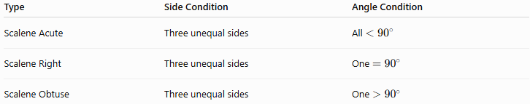
Type | Side Condition | Angle Condition
Scalene Acute | Three unequal sides | All $<{90}^{∘}$
Scalene Right | Three unequal sides | One $={90}^{∘}$
Scalene Obtuse | Three unequal sides | One $>{90}^{∘}$
So a scalene triangle can belong to exactly one of these angle classifications:
$$\boxed{\text{Acute, Right, or Obtuse}}$$

Important Distinction
# Source: AI Source: Provided by: [Data Path: Persons Table -> ID Column: 1, Name_En Column: Motasem Essam] -> From: [ChatGPT] on [7/25/2026]
A scalene triangle cannot have two equal angles.
The converse of the isosceles triangle theorem states that if two angles are equal, their opposite sides are equal.
Therefore:
$$\boxed{\text{Scalene}⇒\text{all three angles are different}}$$
Likewise:
$$\boxed{\text{All three angles different}⇒\text{all three sides different}}$$

Real-World Applications
# Source: AI Source: Provided by: [Data Path: Persons Table -> ID Column: 1, Name_En Column: Motasem Essam] -> From: [ChatGPT] on [7/25/2026]
Scalene acute triangles occur naturally in:
- Land surveying
- Triangulation
- Structural engineering
- Roof and architectural design
- Geographic mapping
- Computer graphics
- 3D modeling projections
- Navigation and positioning
- Irregular triangular plots of land
They are especially useful when three different lengths and three non-right angles describe an irregular triangular configuration.

Key Points
# Source: AI Source: Provided by: [Data Path: Persons Table -> ID Column: 1, Name_En Column: Motasem Essam] -> From: [ChatGPT] on [7/25/2026]
- A scalene acute triangle has three unequal sides.
- It has three unequal acute angles.
- Every angle is less than ${90}^{∘}$.
- The angles sum to ${180}^{∘}$.
- The longest side is opposite the largest angle.
- If $c$is the longest side:
$$\boxed{c^{2}<a^{2}+b^{2}}$$
- It has no line of symmetry.
- Its centroid, incenter, circumcenter, and orthocenter are all inside.
- Its Euler line contains $O$, $G$, and $H$.
- It can be analyzed using the Law of Sines, Law of Cosines, Heron's Formula, and standard triangle-center theorems.

Conclusion
# Source: AI Source: Provided by: [Data Path: Persons Table -> ID Column: 1, Name_En Column: Motasem Essam] -> From: [ChatGPT] on [7/25/2026]
A Scalene Acute Triangle is the combined classification of a triangle that is scalene by side lengths and acute by angle measures. It has three different sides, three different angles, no symmetry axis, and all four principal triangle centers lie inside the triangle. It represents the general irregular form of an acute triangle.

